

**Capstone Project Report**

**Report 1 – Project Introduction**

– Ho Chi Minh, 14 May 2022 –

**Table of Contents**

I. Record of Changes 3

II. Project Introduction 4

1. Overview 4

1.1 Project Information 4

1.2 Project Team 4

2. Product Background 4

3. Existing Systems 4

3.1 System name1 4

3.2 System name2 4

4. Business Opportunity 4

5. Software Product Vision 5

6. Project Scope & Limitations 5

6.1 Major Features 5

6.2 Limitations & Exclusions 6

# I. Record of Changes

|  |  |  |  |
| --- | --- | --- | --- |
| Date | A* M, D | In charge | Change Description |
|  |  |  |  |
|  |  |  |  |
|  |  |  |  |
|  |  |  |  |
|  |  |  |  |
|  |  |  |  |
|  |  |  |  |
|  |  |  |  |
|  |  |  |  |
|  |  |  |  |
|  |  |  |  |
|  |  |  |  |
|  |  |  |  |

*A - Added M - Modified D - Deleted

# II. Project Introduction

## 1. Overview

### 1.1 Project Information

* Project name: Design and implement a management system for a chain of hotels and motels using IoT technology
* Project code: DIMS
* Group name: SU22SE02
* Software type: Software Type: Web, device IOT

### 1.2 Project Team

|  |  |  |  |
| --- | --- | --- | --- |
| **Full Name** | **Role** | **Email** | **Mobile** |
| Nguyen Duc Loi | Lecturer | loind9@fe.edu.vn | 091 674 3939 |
| Nguyen Tan Danh | Lecturer |  |  |
| Le Hong Nguyen | Leader | nguyenlhse130342@fpt.edu.vn | 093 4092 425 |
| Nguyen Quoc Truong Huy | Member | huynqtse140296@fpt.edu.vn | 070 6749 673 |
| Hoang Tuan Anh | Member | anhhtse140335 @fpt.edu.vn | 079 7991 707 |

## 2. Product Background

In today's era when people's economic life is improved and they really focus on activities such as travel, experience, private life. Especially young people today, the demand for renting hotels and motels is very high. They are a group of customers who can access high technology very quickly, often they want the procedures of room rental and check-out to be quick, convenient and private, discreet and comfortable. At the same time, the owners of hotels and motels also want to have more customers access to their services. For the manager of a series of hotel chains, motels they also have to implement a smart management system to easily track all activities there

## 3. Existing Systems

The hotel and motel chain management system applies technology, including functions such as booking, check-in, check-out, payment, budget management and statistics, history tracking…

### 3.1 System name1

Users through the user app to choose a room, choose a reservation date and time, room type, number of rooms, receive a promotional code (if any), make a reservation deposit, make payment, cancel the reservation, change the date and time... After successful registration, the system sends a confirmation message and QC code to the user to open / close the door lock, the code is only valid according to the time the user booked the room.

### 3.2 System name2

The receptionist (hotel staff, motel) uses the image processing system to scan the citizen identification code / national identity card / driver's license, it will get the necessary information of the customer such as: full name, date of birth, permanent address, citizen identification number to manually enter in the form to avoid errors and long waits due to staff typing.

### 3.3 System name 3

Managers (hotel owners or motel owners) can authorize reception staff to access the system, can monitor employee visits, timekeeping, and monitor tenant information. Make detailed spreadsheets and summary tables of income and expenditure from room rental activities, look up the history of information and make graphs. Perform other administrative activities...

## 4. Business Opportunity

In today's era when people's economic life is improved and they really focus on activities such as travel, experience, private life. Especially young people today, the demand for renting hotels and motels are very high. They are a group of customers who can access high technology very quickly, often they want the procedures of room rental and check-out to be quick, convenient and private, discreet and comfortable. At the same time, the owners of hotels and motels also want to have more customers access to their services. For the manager of a series of hotel chains, motels they also have to implement a smart management system to easily track all activities there. The hotel and motel chain management system applies technology, including functions such as booking, check-in, check-out, payment, budget management and statistics, history tracking ...

## 5. Software Product Vision

* Users through the user app to choose a room, choose a reservation date and time, room type, number of rooms, receive a promotional code (if any), make a reservation deposit, make payment, cancel the reservation, change the date and time... After successful registration, the system sends a confirmation message and QC code to the user to open / close the door lock, the code is only valid according to the time the user booked the room.
* The receptionist (hotel staff, motel) uses the image processing system to scan the citizen identification code / national identity card / driver's license, it will get the necessary information of the customer such as: full identification number to manually enter in the form to avoid errors and long waits due to staff typing.
* Managers (hotel owners or motel owners) can authorize reception staff to access the system, can monitor employee visits, timekeeping, and monitor tenant information. Make detailed spreadsheets and summary tables of income and expenditure from room rental activities, look up the history of information and make graphs. Perform other administrative activities, ... In the context of more and more motels and hotels, finding a source of customers is extremely difficult. That's why we need a difference to be able to create something new and experience for our customers. Just like for customers, finding affordable, safe, comfortable, private and transparent accommodation has always been a difficult problem to solve. DIMS was born not only to solve these basic difficulties but also to give customers a new experience in renting rooms.

## 6. Project Scope & Limitations

* We will create a website for users to view room information, search and book rooms, make payments, and check booking history. After booking, there will be an email providing QR code to customers. They will be able to use that QR code to check in and open the door of their booked room.
* We will build a check-in system by reading a QR code, then reading the customer's identity card in turn to complete the check it procedure. And the door has a built-in QR code reader feature so customers can use it to open the door.
* Finally, we will build a website for hotel owners, apartments, accommodation service providers giving us a system to use, change, add, edit, delete rooms, change room rates, status room, and most importantly, we provide our partners with a system for revenue statistics, customer statistics.

**6.1 Major Features**

*[Include a numbered list of the major features of the new product, emphasizing those features that distinguish it from previous or competing products. Specific user requirements and functional requirements may be traced back to these features.]*

<<Sample:

FE-01: Order and pay for meals from the cafeteria menu to be picked up or delivered.

FE-02: Order and pay for meals from local restaurants to be delivered.

FE-03: Create, view, modify, and cancel meal subscriptions for standing or recurring meal orders, or for daily special meals.

FE-04: Create, view, modify, delete, and archive cafeteria menus.

FE-05: View ingredient lists and nutritional information for cafeteria menu items.

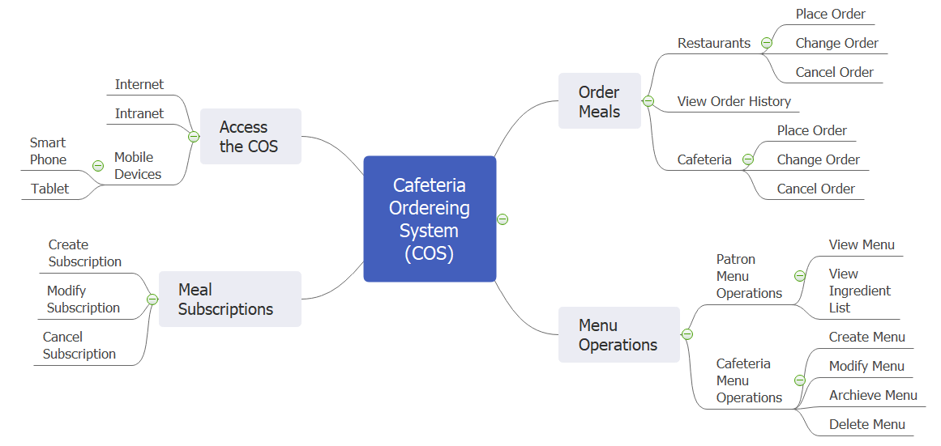

>>

### 6.2 Limitations & Exclusions

*[Identify any product features or characteristics that a stakeholder might anticipate, but which are not planned to be included in the new product.]*

<<Sample:

LI-1: Some food items that are available from the cafeteria will not be suitable for delivery, so the menus available to patrons of the COS must be a subset of the full cafeteria menus.

LI-2: The COS shall be used only for the cafeteria at the Process Impact campus in Clackamas, Oregon.

>>